|  |  |
| --- | --- |
| Team ID | PNT2022TMID31573 |
| Project Name | Inventory Managment System For Retailers |

**1. Create IBM DB2**

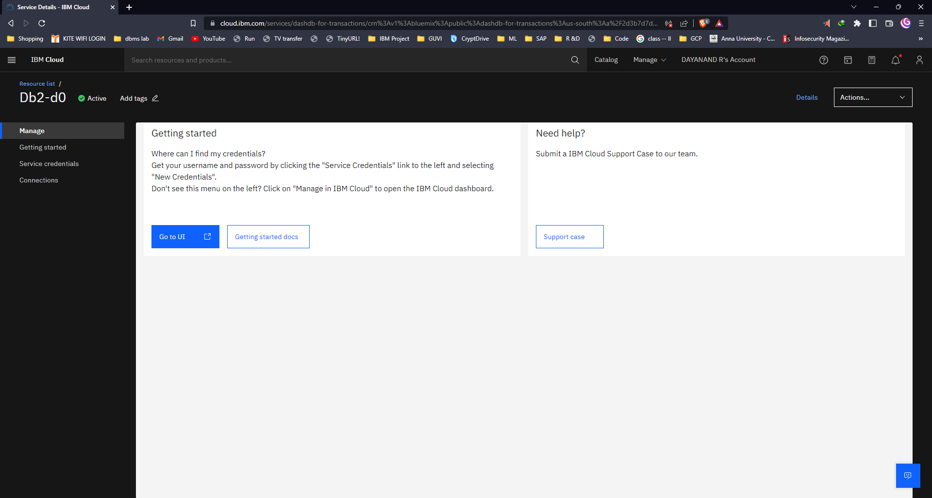

**2. Connect with python**

